Appointment Prioritisation for Health Checks in People with Learning Disability
URGENT
Arrange investigations and encourage initial face to face consultation
- Pre-existing comorbidity:
  - Type 1 or Type 2 DM aged >40 years with HbA1c >75 and/or
  - Chronic Renal Failure: eGFR <40 and/or
  - On Disease modifying drugs including psychotropic medications
- Patients who have multiple co-morbidities (e.g. Epilepsy, Hypertension, CVD, HF, BMI < 19 or >40)
- Hx of Aspiration Pneumonia/recent admission (last 6 months)/PEG feeding

(Consider home visits for those categorised as shielding or Housebound)

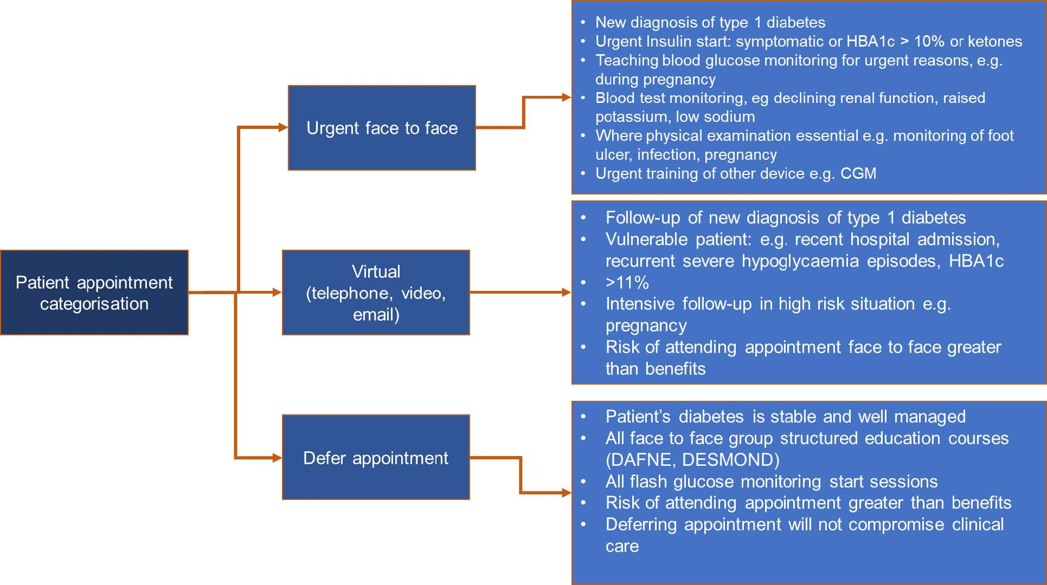

Appointment Categorisation

VIRTUAL TRIAGE
(Telephone or Video consultation)

- Follow up appointment where recent bloods are available (last six months-FBC, Renal, TFT, HbA1c)
- Non-attenders (last six months)
- Patient not included in URGENT List above and STABLE list below
- Patients usually under the care of specialist services
- Nursing and residential Care setting (24/7 care)

STABLE

Defer Appointment and send safety netting letter/SMS
Stable and well managed patients e.g.
- No comorbidities identified
- Not on medications?

Other risk factors to consider:
- BAME groups?
- Transition?
- Previous/ongoing Safeguarding concerns
- Scoliosis?

- To do as much preparation remotely and in advance as possible. This will mean the face to face contact can be minimised.
- Consider appointment when there is minimal other patient activity in the surgery; eg avoid coinciding with other F2F clinics (ie blood clinics, antenatal clinics etc)
- Consider 1st appointments of the day (ie no footfall yet in the surgery, surgery has been cleaned, so less chance of cross-contamination)
- Consider using Extended Access clinics / Improved Access clinics (less footfall)
- Consider using a dedicated Saturday clinic
- Consider practitioner going to people in their care homes/supported living rather than they come to the surgery. Particularly if they have more than one patient in each placement.
- Consider doing all LTC health checks at the same time as the AHC.

Practical tips to advise patients/carers before attending the surgery
- To warn that PPE will be worn by staff
- 2m distancing of staff and patients is encouraged where possible.
- Patents and carers will be asked to wear facial covering.
- Patient (and carer) go to the toilet before attending (if possible)
- May be asked to wait in the car rather than sit in the waiting room (although will try and be seen promptly)
- May need to ring the doorbell to be let in by staff.
- To bring health questionnaire (if not already sent in)

Useful Resources:
https://www.getcheckedoutleeds.nhs.uk/
Suggested Reasonable Adjustments to consider at ICS/CCG/PCN/Patient level
      - Development of Searches within EMIS to support above approach
      - Use of software to support patient/carer engagement with health and social care systems e.g. https://www.myhealthguideapp.com/
      - Support use of Microsoft Teams across settings for an integrated approach (Primary, Secondary and Community)
      - Provision of point of care testing gadgets to support clinical assessment:
        - Patient level: Digital thermometers, BP machines, Pulse Oximeters
        - PCN level: POC testing machines

